Assignment-25.3:

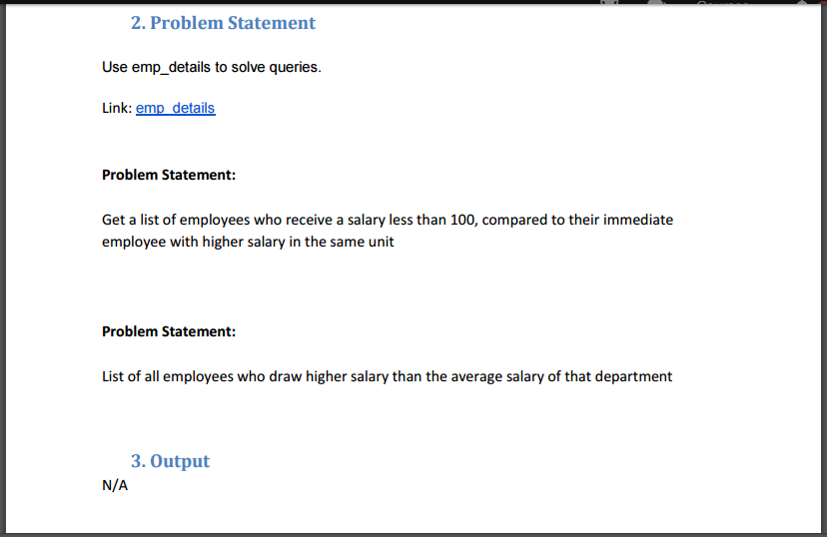

A table named emp_salary is created with columns id, name, salary and department. And then the data is loaded into the table. The contents of the table is displayed.

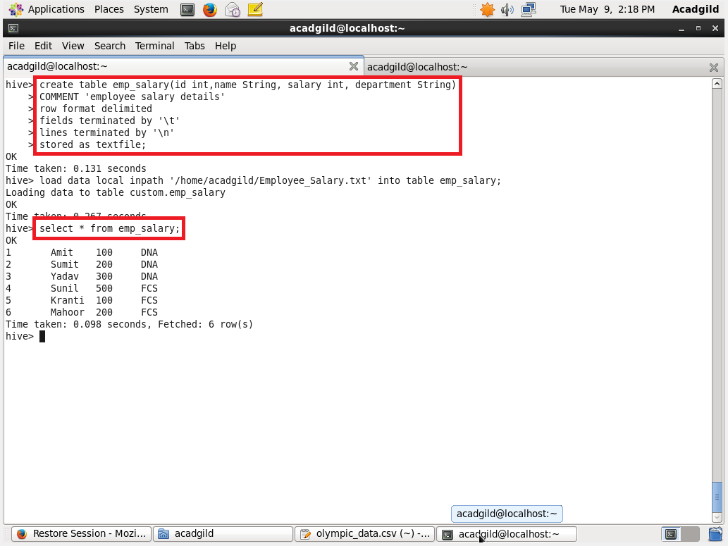

Question: Get a list of employees who receive a salary less than 100, compared to their immediate employee with higher salary in the same unit

Since we want persons with salary less than 100 compare to immediate employee with higher salary. we are creating a view named emp_salary_vw where by using lag function and partitioned by department and order by salary we are creating a column as previous as shown below

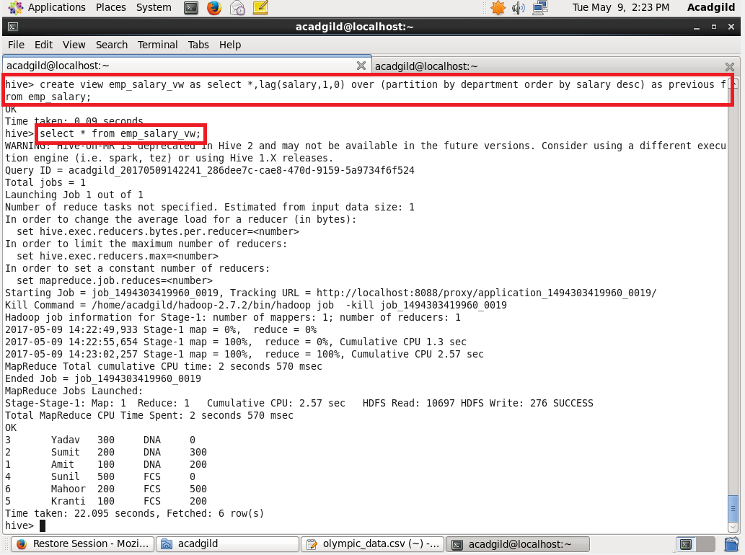

We are just filtering with where clause as (previous- salary)>100

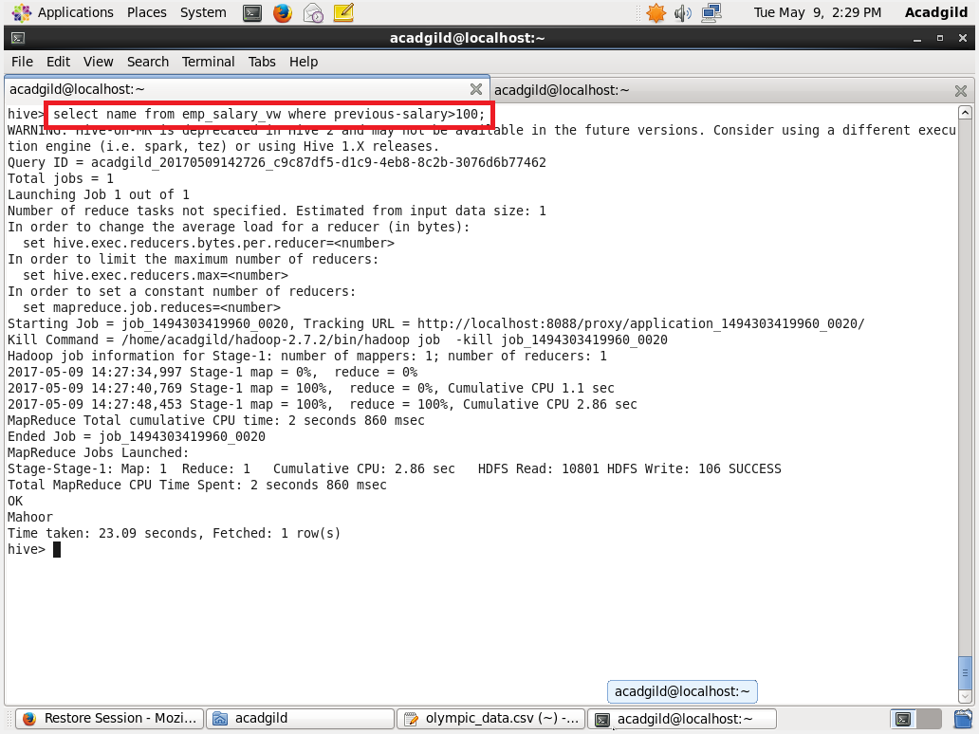

Question: List of all employees who draw higher salary than the average salary of that department

Step-1: A view is created where average salary is found department wise.

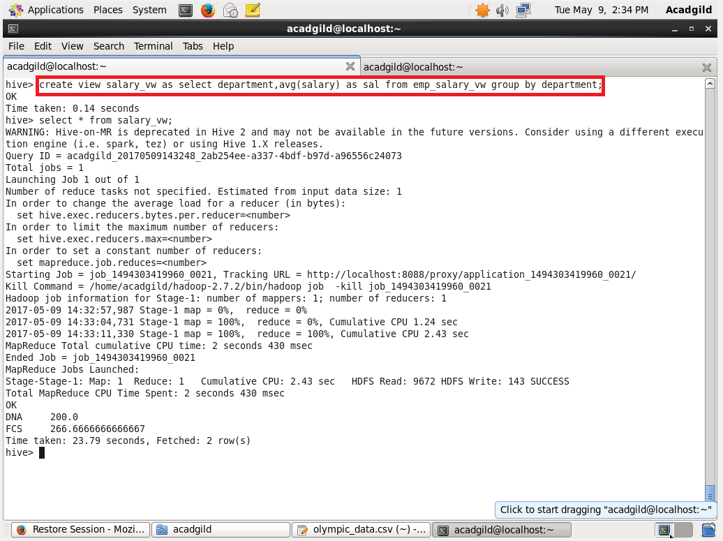

Step-2: The view table is joined with emp_table based on department and finding the employees who are having salary greater than avg salary

